**Manhole Detection and Monitoring System**

**By: Surya Narayanan CS**

**Sanjay S**

**Sagul Hameed A**

**Theme**: **IoT Based Manhole Detection**

**Department of ECE**

**Problem Statement:**

Today's drainage system is not high-tech. So, whenever there is blockage, it is difficult to figure out the exact location of the blockage. Also, early alerts of the blockage are not received. Hence detection and repairing of the blockage become time consuming. It becomes very inconvenient to handle the situation when pipes are blocked completely. Due to such failure of drainage line people face a lot of problems.

**Solution:**

Underground monitoring is challenging problem. Our project proposes different methods for monitoring and managing underground drainage system. It explains various applications like underground drainage and manhole identification in real time. Various parameters like temperature, toxic gases, flow and level of water are being monitored and updated on the internet using the Internet of Things. This enables the person in-charge to take the necessary actions regarding the same. In this way the unnecessary trips on the manholes are saved and can only be conducted as and when required. Also, real time update on the internet helps in maintaining the regularity in drainage check thus avoid the hazards.

**Introduction**:

An integral part of any drainage system is the access points into it when it comes to cleaning, clearing, and inspection. Metropolitan cities have adopted underground drainage system and the city’s municipal corporation must maintain its cleanliness. If the sewage maintenance is not proper, ground water gets contaminated causing infectious diseases. Blockages in drains during monsoon season, causes problems in the routine of the public. Hence, there should be a facility in the city’s corporation, which alerts the officials about blockages in sewers, their exact location. It mainly acknowledges in the field of alerting the people about the gas explosion, increase in the water level and the temperature level. It uses IoT to make the drainage monitoring system in a highly automotive by using sensor for detecting and sending alerts through GSM and GPS module to the authorities. This project overcomes the demerits by detecting drainage water blockage by installing water flow rate sensors at the intersection of nodes.

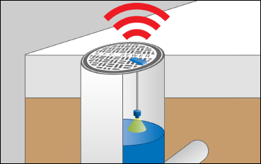

**Objectives:**

* Cleaner cities and intelligent management of drainage in the city.
* Detection of drainage water level and blockages in the drainage.
* Checking water flow rate continuously, as well as sending automatic mail, display on the monitor if the water level is outside of an expected normal range.
* The main objective is to obtain an effective low-cost and flexible solution for condition monitoring and infrastructure management in the city.
* Sensing the temperature and leakage of gas and updating it in real time through IoT.

**System Design:**

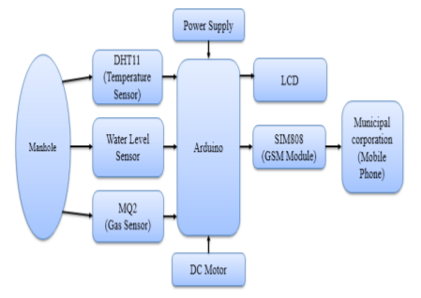

**System Specifications:**

|  |  |
| --- | --- |
| **Software used** | **Hardware used** |
| Simulation Proteus & Professional | Arduino UNO |
| Arduino | Temperature Sensor (DHT 11) |
|  | Water Level Sensor |
|  | Gas Sensor |
|  | LCD |
|  | DC Motor |
|  | Adaptor |
|  | 12V Relay Module |
|  | GSM Module (SIM 808) |

**Working:**

An underground drainage monitoring system will not only help in maintaining the proper health and safety of the city but also in reducing the work of government personnel. Various types of sensors (flow, level, temperature and gas sensors) are interfaced with microcontroller Arduino Uno in order to make the system smart. When the respective sensors reach the threshold level, the indication of that respective value and sensor is being sent to the microcontroller. Furthermore, Arduino Uno then sends the signal and location of the manhole to the municipal corporation through GSM and GPS and the officials could easily locate which manhole is having the problem and could take appropriate steps. Also, Arduino Uno updates the live values of all the sensors in the manholes falling under the respective area using IoT. A message will also be displayed on the LCD.

**Flow Chart:**

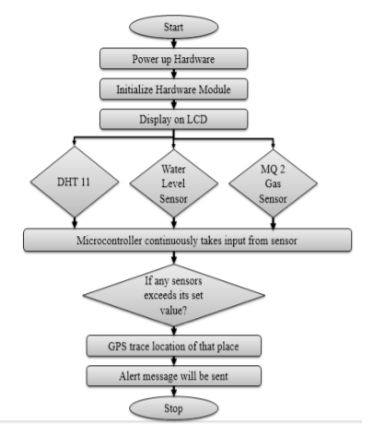

**Conclusion:**

A smart city is the future goal to have cleaner and better amenities for the society. Smart underground infrastructure is an important feature to be considered while implementing a smart city. Drainage system monitoring plays a vital role in keeping the city clean and healthy. Since manual monitoring is incompetent, this leads to slow handling of problems in drainage and consumes more time to solve. To mitigate all these issues, the system using a wireless sensor network, consisting of sensor nodes is designed. The proposed system is low cost, low maintenance, IoT based real time which alerts the managing station through message when any manhole crosses its threshold values. This system reduces the death risk of manual scavengers who clean the underground drainage and also benefits the public.